**Task 3 – Website development report**

**Mohammed Mahin Ibnay Mamun / 346584**

**Introduction to developing a website**

The purpose of this report is to explain and document the process of developing and testing my website, During the test phase and on the website, I will explain my reasoning for some actions which were made and those which were changed.

Replit 2016 is the website building software which I planned to use to develop my website. I also tested the site with Microsoft edge and Google Chrome web browsers. Despite checking if it appeared differently from one browser to another, I found that it did not.

Compatibility is one area which can have unexpected outcomes while developing the website, as I will need to take compatibility into account.

**Evidence of producing a website**

**Navigation bar**

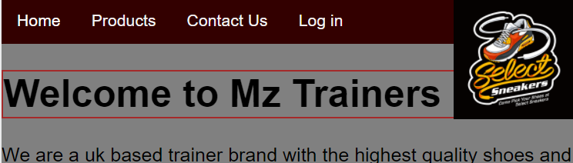

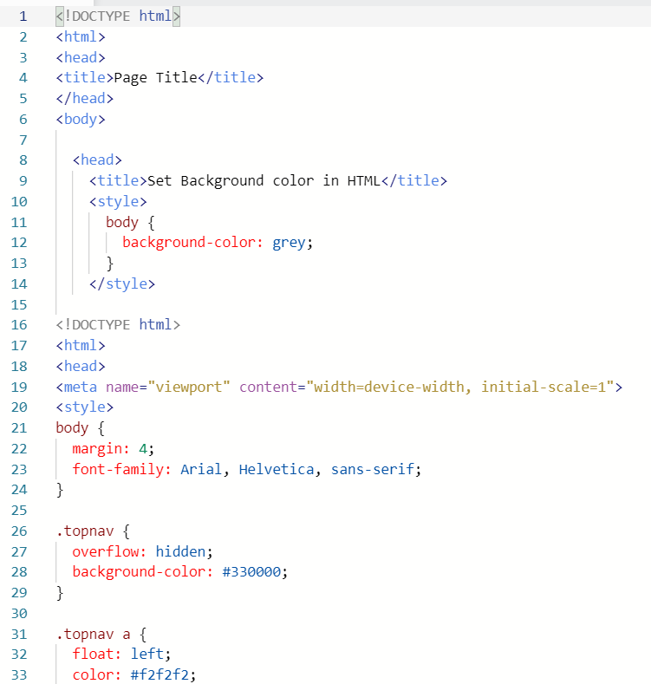

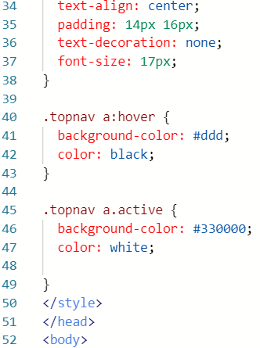

**Images**

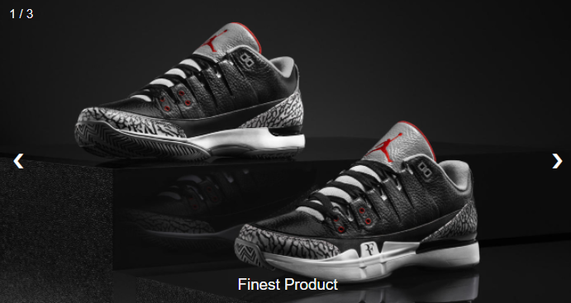

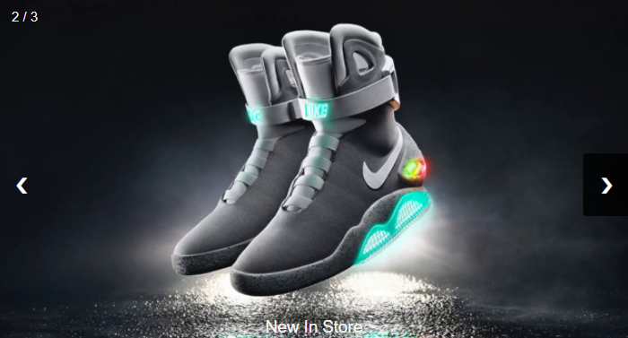

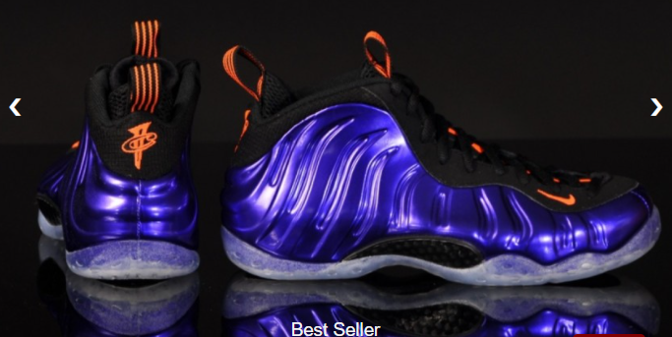

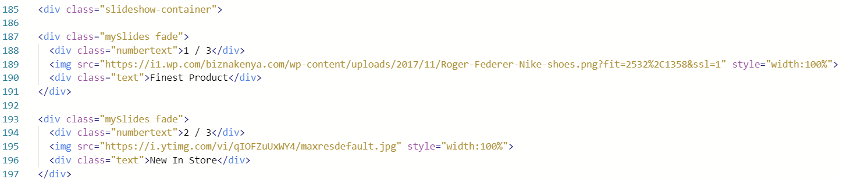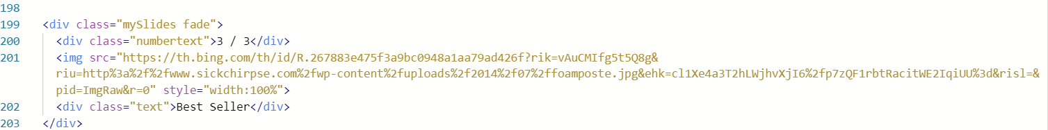

In line 185, you will see the code for the images above. As you can see, the images above are combined into a slide show. This slide show successfully works by clicking the arrow on the side of the image. I have also used these images on my product page. Below is a screenshot from my product page.

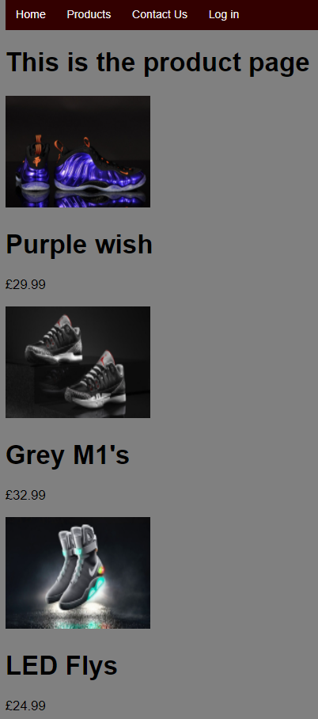

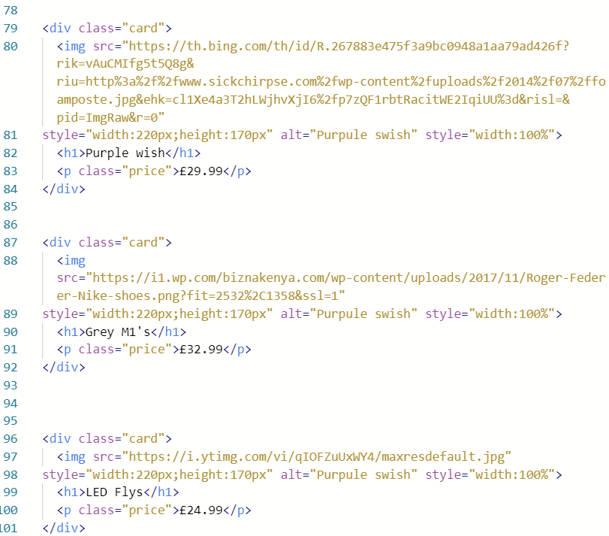

The code above is a screenshot of my product page. This shows that I have included an image with the heading of what the item is called, and I have created a class called price which displays the price of the item.

**Subpages**

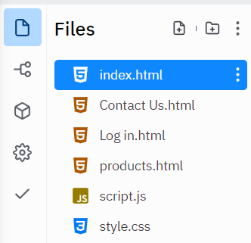

As the screenshot above shows, I have added more than one file on my website, the reason for this is because I have subpages. T These codes are not visible on the website, but you can see them on my website's navigation bar. Below is a screenshot of how the navigation bar looks for the subpages on my website

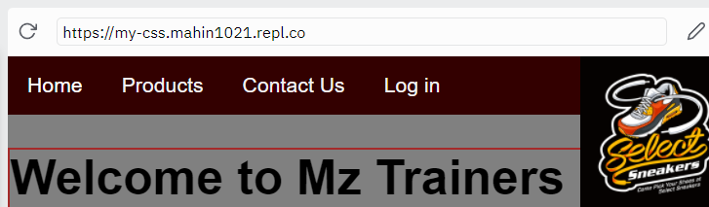

I have this on every page of my website. As I have three subpages - products, contact us, and log in - I want to make my website as accessible and navigable as possible.

You can see how I made this appear by using the code below.

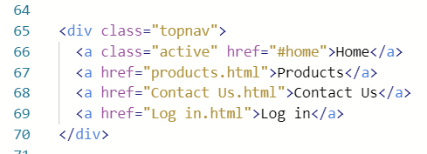

**Contact us page**

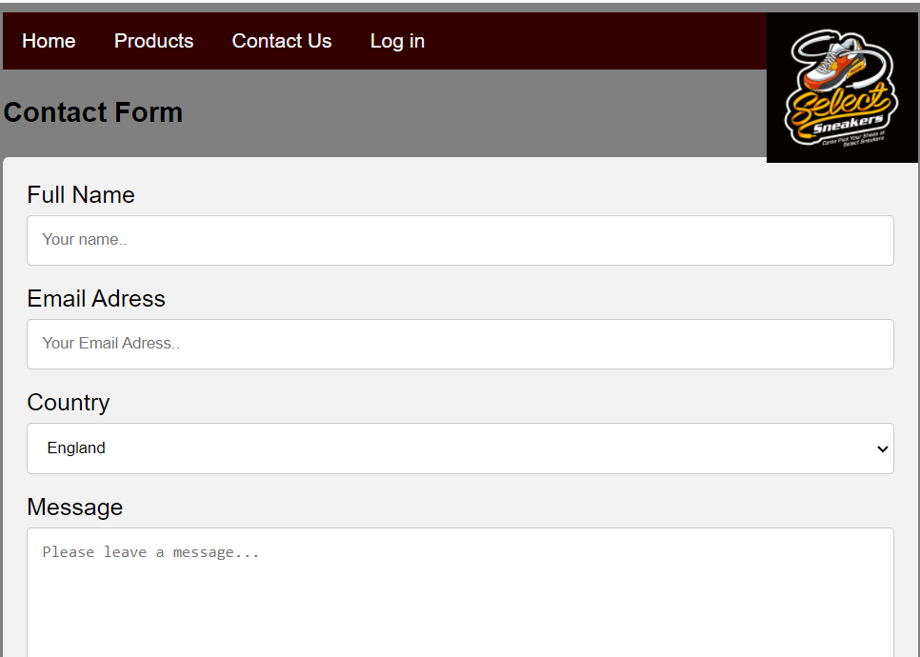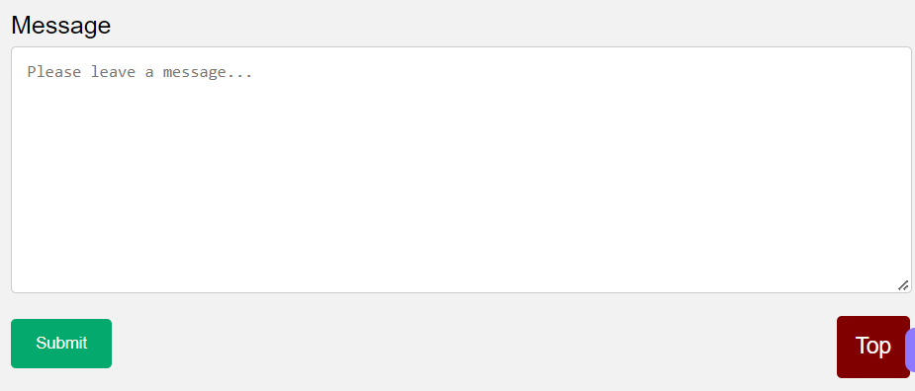

As you can see, I have created a form on my contact us page. To do this, I had to code out heading and boxes. On the country tab, I have added a scroll down feature, I also had to code this. Here is some evidence of my code.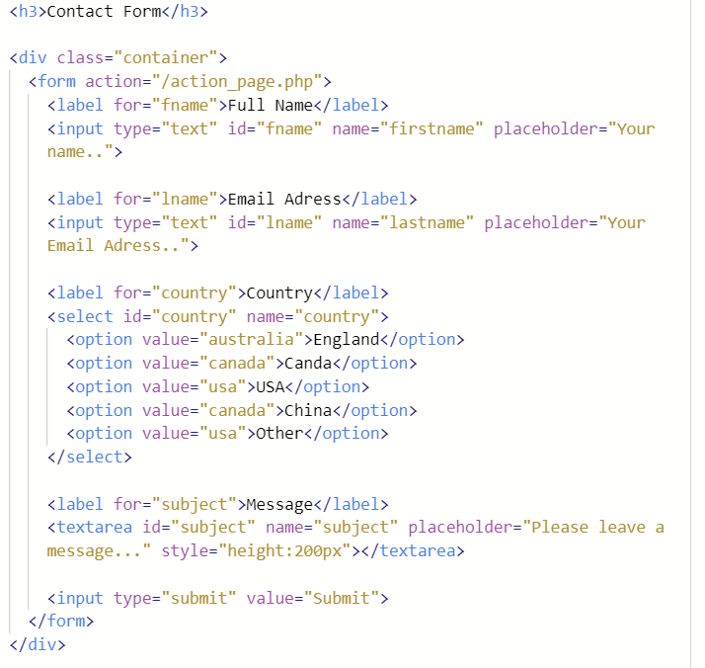

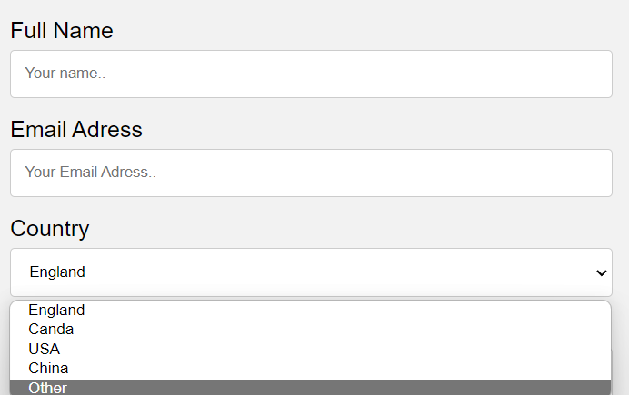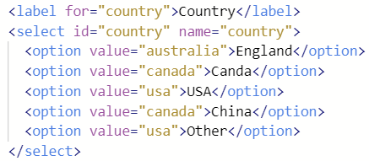

To create a scroll down option, I had to add this specific section of code.

**Log in page**

My current log in page looks like this:

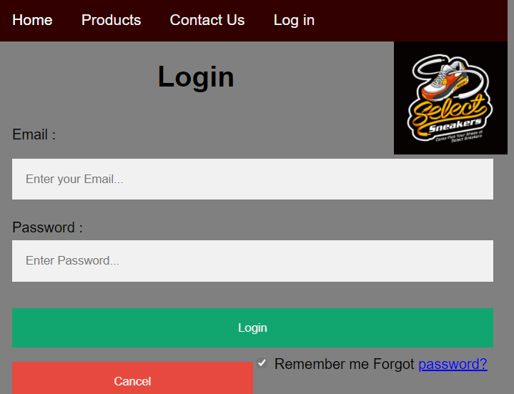

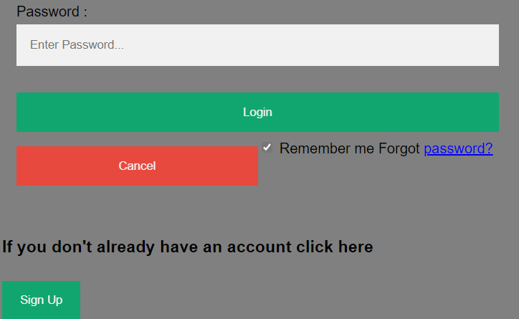

Here is the code which I used to create this layout.

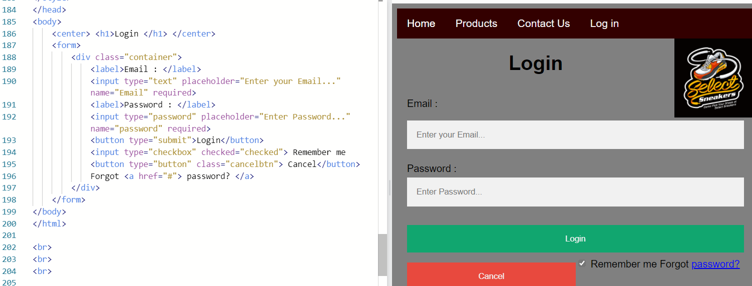As you may also be able to tell there is a sign-up button at the bottom of this page, this button will redirect you to a new form which can be filled in to create your account I will also provide a screenshot of this with the code which was required to create the form.

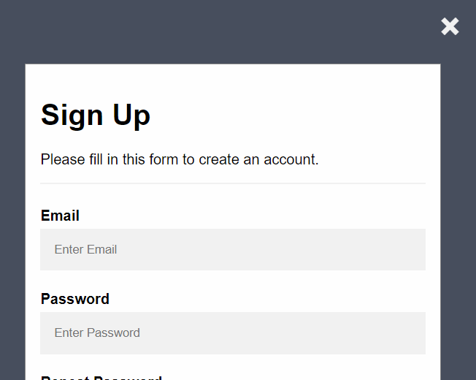

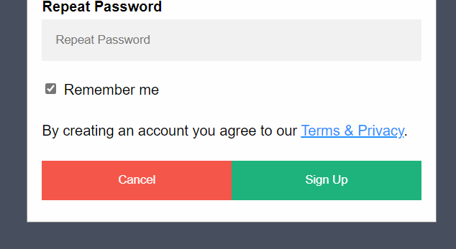

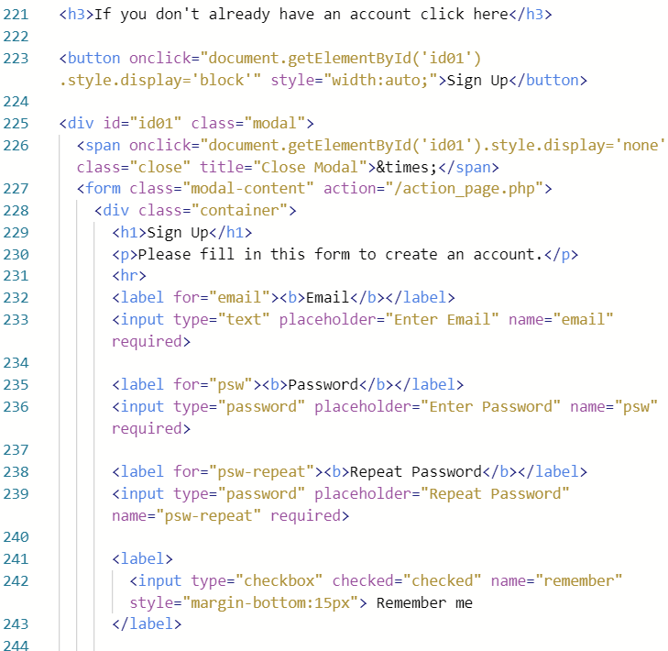

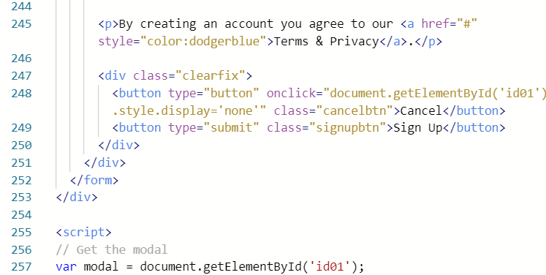

**Hyperlinks**

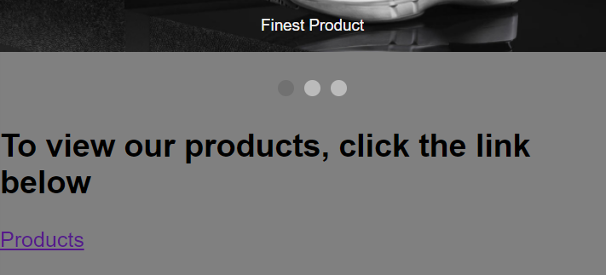



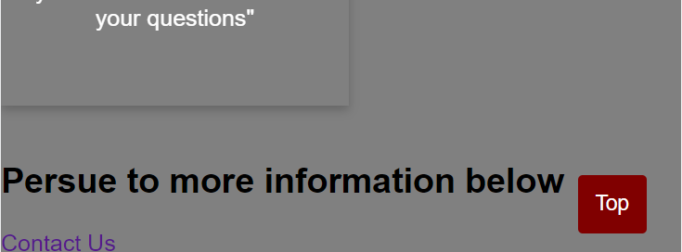



By clicking on the hyperlinks, it automatically redirects you to the subpage.

**Description**

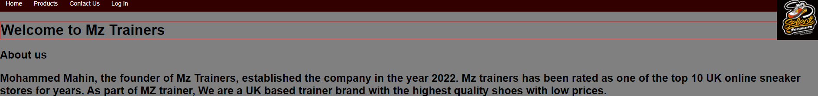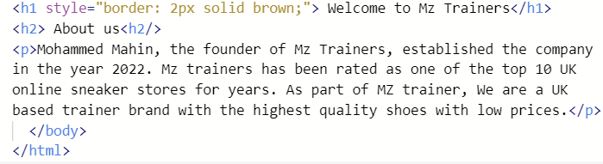

**CSS**

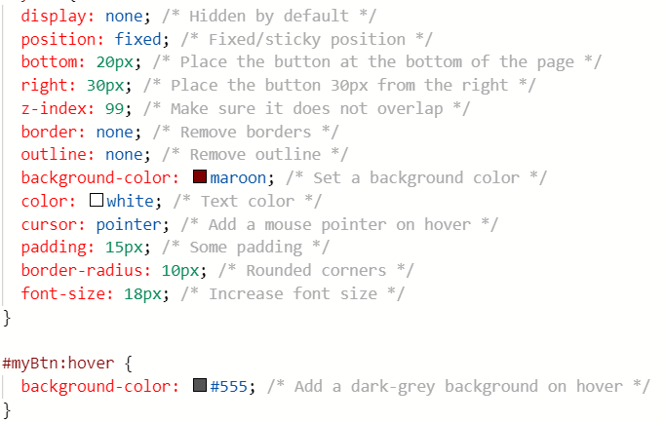

**Interactive Features**

1) navigable slide show.

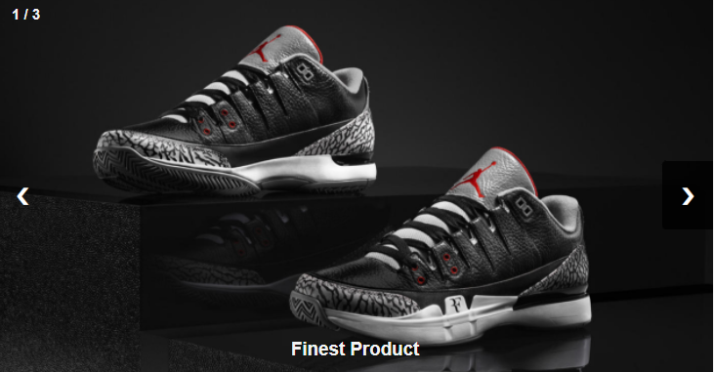

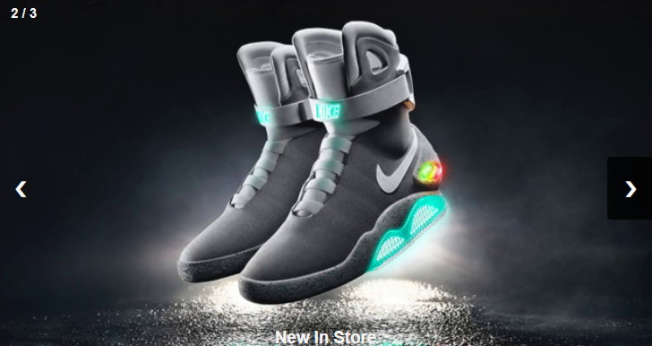

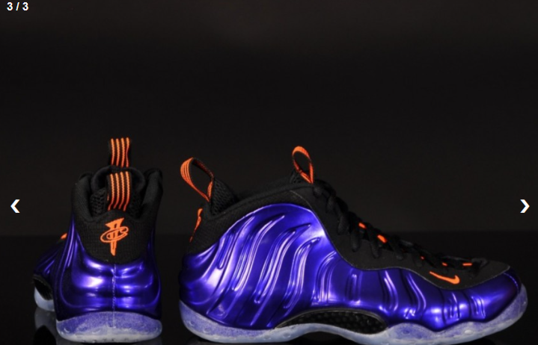

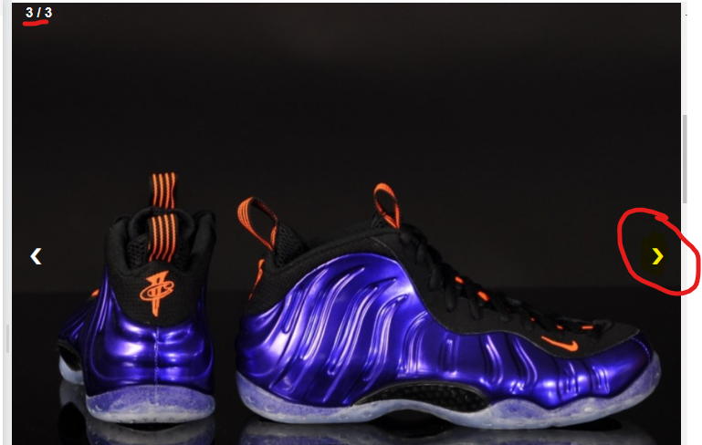

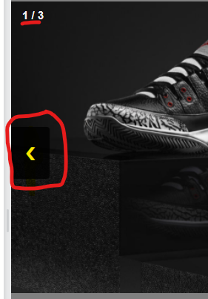

**Original testing plan for the website:**

|  |  |  |  |  |
| --- | --- | --- | --- | --- |
| Testing item | page | Results expected | Actual results | Pass (y/n) |
| 1) navigation bar | all | Should appear on each page and work | Appears on all pages and redirects from one page to the other | y |
| 2) buttons | Login page | Expect button to redirect and submit button to work | Buttons working which brings up a form and submit button also works | y |
| 3) images | Products page and homepage | Images should appear and should take you to image description when clicked | Images are visible and when you press the image it redirects you to the products page showing the image | y |
| 4) links | homepage | 1 link for product page 1 link for contact us page | Both links work and allow the user to navigate to the page | y |
| 5) Forms | Contact us page and login page | Required information is needed to submit form | When the user leaves an empty section on the form, it will not submit, and it informs the user | y |
| 6) hover effect | homepage | Flip cards at bottom should turn over when users hover over them | When a customer goes down to the flip cards, the cards turn around revealing information | y |

**Testing evaluation:**

After testing the website, I am pleased to report that all features work properly. I tested the navigation bar, the buttons, forms, and links. They are all working successfully.

It was difficult for me at first to use the navigation bar to go from any other pages to the homepage, but eventually I worked out this bug and I was able to use the navigation bar again. This code was not present on each subpage, which explains why it was not working at first.

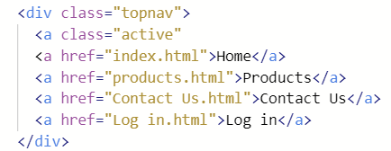

**Review**

In reviewing my website design, I discovered two major concerns: copyright and search engine optimization. I will find more ways to optimize seo, for example, headings, paragraphs with keywords related to computers, links, etc., to improve this.

To protect the copyright of the website, I will make sure I only use assets that are copyright free, or that I pay the owner a fee, or ask their permission, to use their content. However, I will try to maximize the design to the maximum.

As part of our review, I was also told to create a wireframe that would give me an idea of what my website should look like. I should create several wireframes, one for each page, and add annotations or notes to assist in the design.

**Optimization**

**Wireframe before and after:**

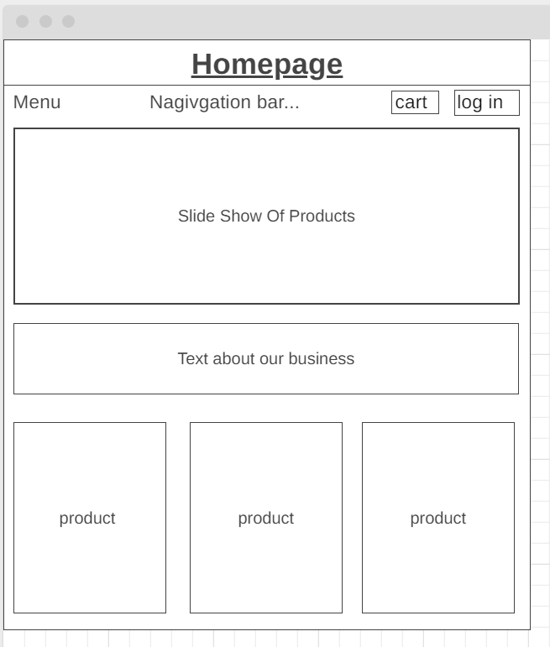

Here is my first ideal homepage wireframe. I created all my wireframes through an online website called wireframe.cc. My wireframe clearly shows that I have a menu and navigation bar and a cart and log in button at the top. On the homepage, I will include 3 images to promote my products in a row. Additionally, I have created a rectangular box to show a slide show. Below the slide show, I will include some general information about the business and what we offer.

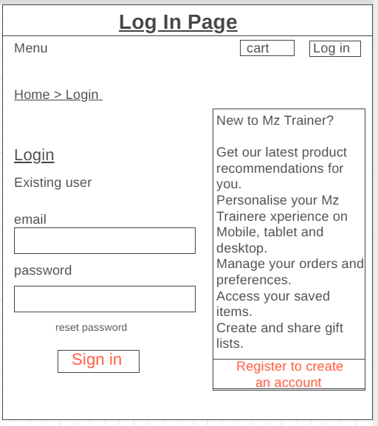

As you can see, I plan to keep the cart and login button at the top of my first login page wireframe. On the right-hand side, I have added a text box that informs clients about our store and has an interactive register button. For existing users, I have added two interactive text boxes and a sign in button Aswell as a reset password button.

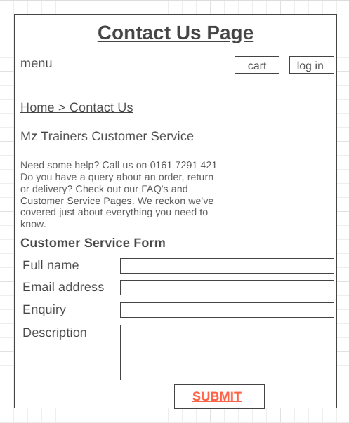

I have kept the cart and log in buttons in the contact us page. I once again like the log in page. I have also included an interactive form and a submit button on the page explaining how the client can contact us.

These are images of the initial wireframes I created. These were created before I reviewed my design and before I built the website.

**Improved Wireframes:**

On this page, I am adding screenshots of wireframes that I have improved from my original wireframes. I have acted on my feedback from my reviews, and I have now recreated improved wireframes.

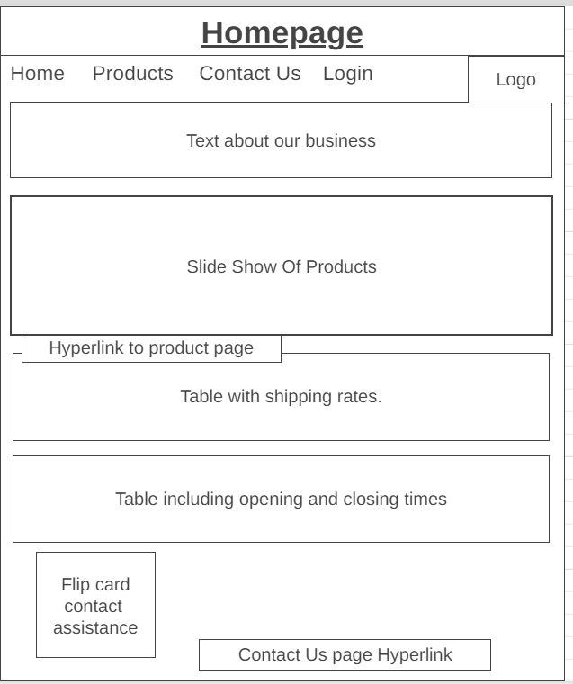

On my homepage, after reviewing I have decided to create a navigation bar with the tabs: home, products, contact us and login. I will also create my own unique logo and add it in the corner. This was a suggestion by my review. I will also keep the slideshow as planned. However, I am going to add a table with shipping rates and a table to show opening and closing times. My reviewer requested that I create a business card and it is a clever idea therefore I have made it accessible, so it flips the card. There will also be a link to the conc=tact us page.

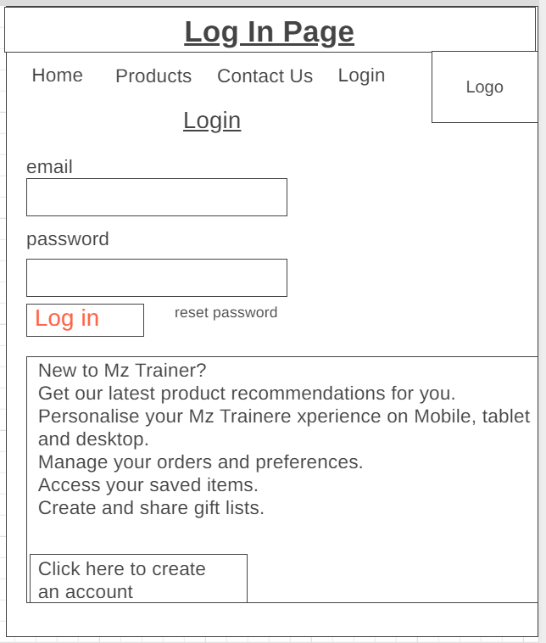

My login page looks similar because the review linked the idea of it. They said it would be better to stack the information below rather than beside. I also agree and think It looks better like this. Other than that, everything else is the same.

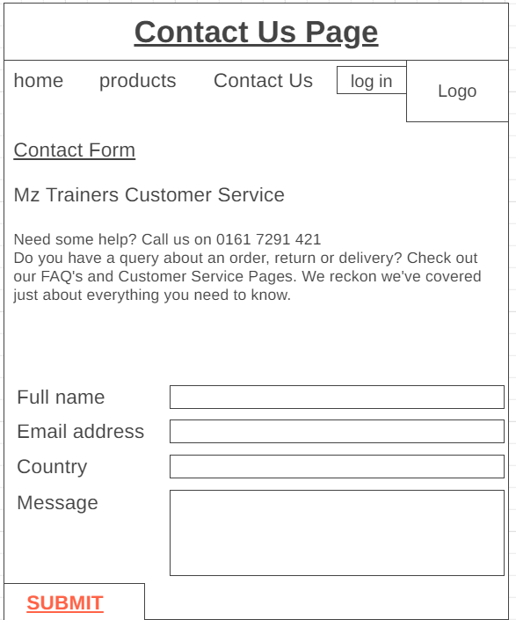

As you can see from the screenshot above, there was only 2 things added to this wireframe compared to the first version.my reviewer reminded me to have a navigation bar on this page or else the client will not be able to another page. Therefore, I added the same navigation bar once again to this page. I also added a logo.

**Legal and ethical requirements**

I made sure to keep the legal and ethical requirements in mind throughout the design and development process. Among other things, I used clear, recognizable layouts (header and footer) on the website to follow accessibility standards. Having content and navigation at the top of the page will make it familiar to any visitor who visits the website for the first time.

Furthermore, I have included accessibility features in my website, such as alternate tags, so people with poor internet access can easily access the website. When designing the website, I made sure that I stayed within the color scheme, I was careful not to make it too dull or too vibrant.

**Evaluation**

**Evaluation of the design and optimized website against client requirements.**

**AND**

**Evaluate the design against client requirements.**

One of the major requirements I was asked to add by my client was a navigation bar to make my website more accessible and navigable. Therefore, I added 4 subpages which are home, products, contact us and login page. Each of these subpages are working and they are accessible from each page. For example, I can navigate from my product page to the contact us page and back.

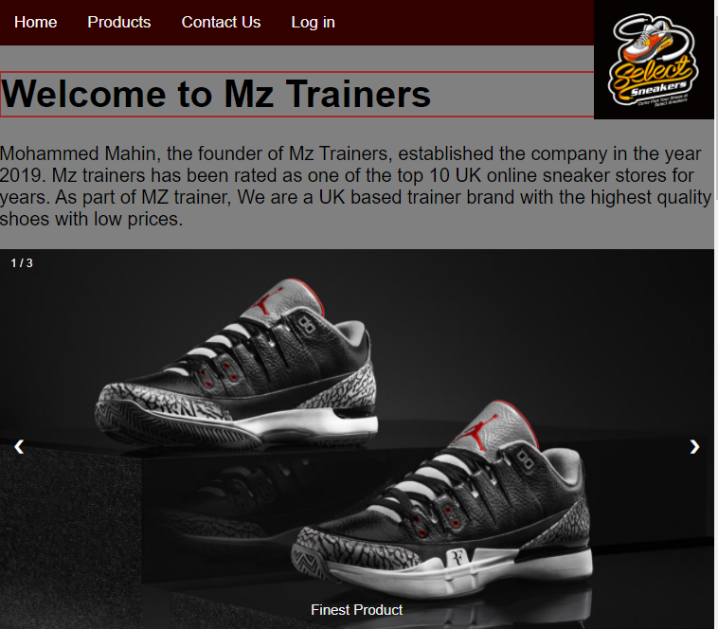

Adding a product page was prompted by the fact that I was told by my client that they wanted a convenient way for customers to view all their products and their prices. Therefor I have created, as my client asked, a subpage which can be accessed from the hyperlink on the homepage or from the navigation bar. If anyone clicks on the link below which says products, the website will automatically redirect the user to the product page.



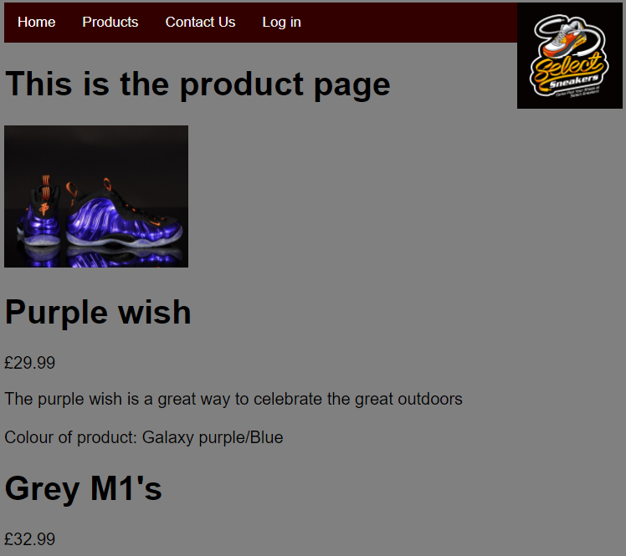

The back to top button was also one of the features that were highly recommended to my website. When this button is clicked, the page will automatically scroll to the top. This is particularly useful with online websites which have many pages. It makes sense for me to add this feature to each of my subpages so that my entire website remains consistent. I have added this button on each of my subpages on the website and the button successfully takes the user to the top of the page.



In response to my client's request, I have included at least one form on my contact us page and on my login page. Here is a screenshot of the form which I created for my contact us page. This form has 4 boxes. The first box asks the user to enter their full name. The second box allows the user to enter their email address.

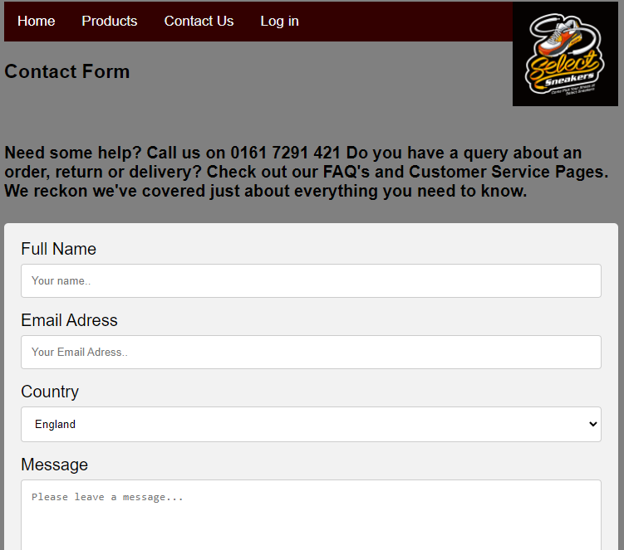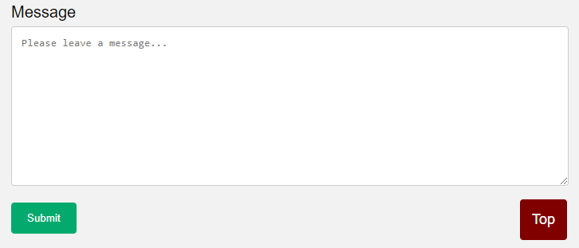

Here is the html code which I added to create this from.

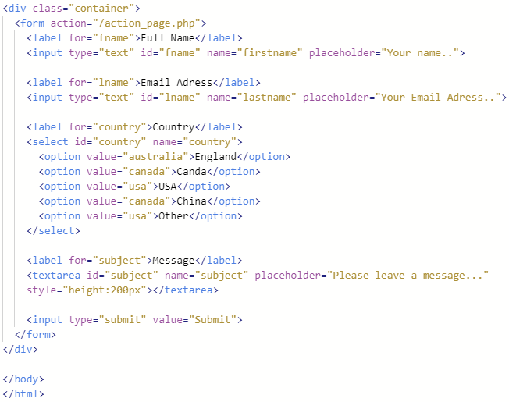

A sign-up form is available at the bottom of my login page.

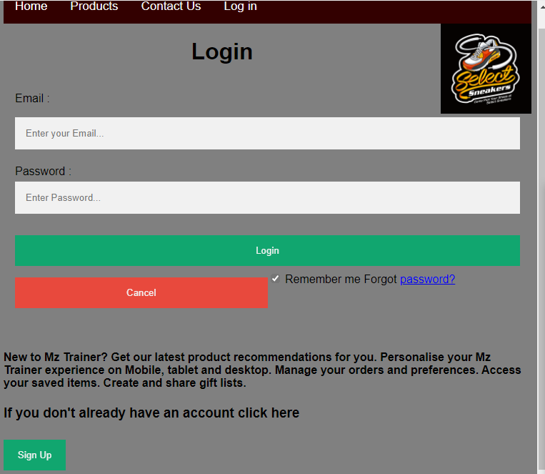

After clicking on the sign-up button, a user will be redirected to this form.

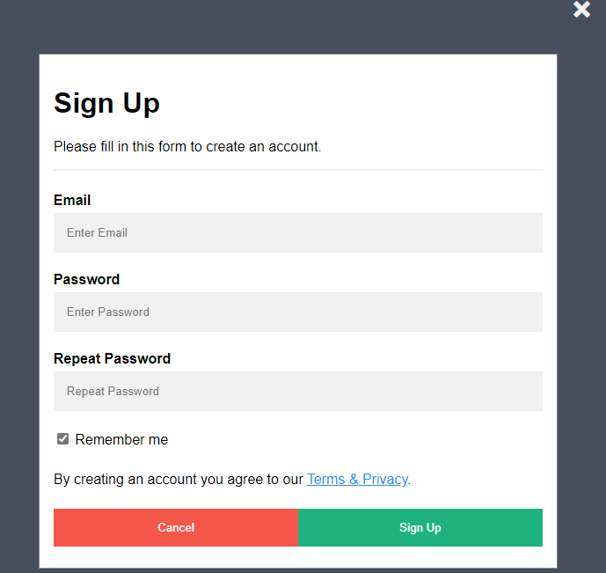

Here is the code which I used to make this form

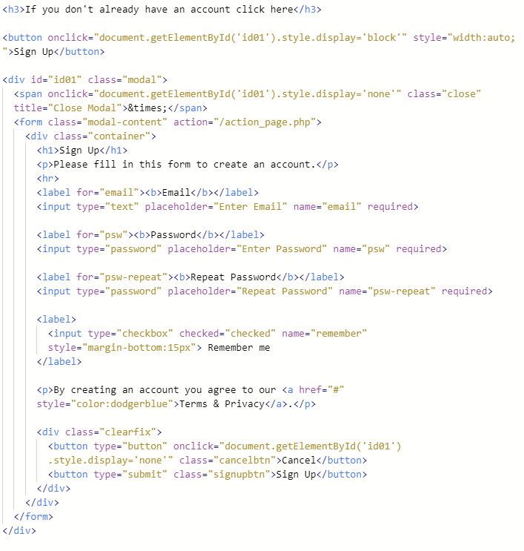

**Overall, from designing the website to developing it, how do you think you managed time?**

In the process of designing my website, I spent most of my time on my website's homepage and navigation. This meant I prioritized the most important tasks for the website first. It was important to make my homepage first since it will be the first impression on my website. A good-looking homepage can attract customers; on the other hand, a poor-looking homepage can lose them. Unfortunately, I had to reduce my description on the homepage because spending more time on the homepage led to losing time for the subpages.

Overall, I managed to complete my website with Mutiple pages, forms, images, and descriptions within my given time.

**How did you show that you were responsible and creative throughout?**

Through my website development, I have demonstrated that I have been aware of and considered important aspects such as target audience, SEO (Search Engine Optimization), and benefits and constraints. Using this method, I created an effective ecommerce webpage that met the needs of my clients

I have also shown that I have been creative by planning my use of media assets on the website. I designed every asset including icons, product page, images, and a logo. I designed the layout and color scheme of the web site during its initial planning. Each web page has a consistent style, which is reflected in the web design throughout.

**Did you feel pressured at any point? If so, how did you work under pressure?**

Since I had less time to develop some of the subpages for the website, it could have led my final web design to not be consistent due to the lack of time. Due to my lack of time, I could not develop certain subpages for the website, resulting in a less consistent final design.

As I was not very experienced nor confident using web development and HTML at the start of this task, I felt a bit of pressure. However, I managed to pick it up quickly in my spare time.

**What do you think you did well?**

During the development of the website, I did well in developing assets for my website, I used various tools to help to develop and change the assets.

I also think I did well with my flip over cards. This is because I managed to make it work and it included an image and description on the other side of the card.

**What went wrong? How did you fix it?**

Due to my lack of consideration for browser compatibility at the development stage of my website, the site looked different in different browsers and on different devices. Fortunately, I was able to fix the problem with various configurations, such as a ratio and resolution.

The navigation system also had some problems. As a result, I could only navigate from the homepage. If I used the homepage navigation bar to go to another subpage it would work, but from my subpage I could not navigate anywhere else. It proved to be a simple fix, and I was also able to figure out why this problem occurred. This took place because the code was in the index.html code (homepage) but not in the subpages.

**What would you do differently to your website?**

It would make sense to me to redo the website product page layout, as it is currently structured vertically with images stacked. I would change this by showing the products in a horizontal format instead.

**For the future, what else would you add to your website?**

It would be great to add a button and a subpage in the future. This button would allow the user to add products to their basket. The new subpage, accessible through the navigation bar, would let the user view their basket.

**DEVELOPMENT NOTES:**

**Differences between HTML5 and HTML**

A markup language called HTML stands for hypertext markup language which was originally intended to be used when designing documents and is now used on websites. Hypertext markup language has been the standard for most websites for decades.

HTML5 is HTML's latest version, and HTML5 is the most up-to-date version of HTML. HTML needs to be changed and updated frequently.